

Republic of the Philippines
LEYTE NORMAL UNIVERSITY
College of Education
P. Paterno St. 6500

CURRICULUM VITAE

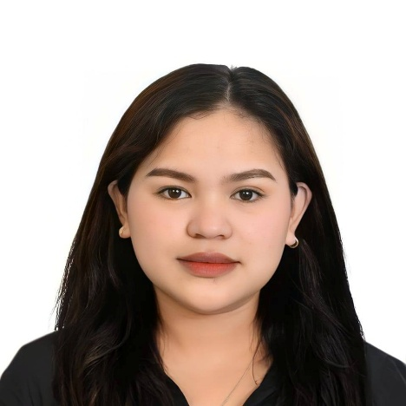
JOYCE B. SABUGAR
Brgy. 103 Palanog, Tacloban City, Leyte
sabugarjoyce@gmail.com
09355175107

PERSONAL PROFILE
Date of Birth : May 24, 2000
Place of Birth : Tacloban City, Leyte
Citizenship : Filipino
Sex : Female
Age : 25
Civil Status : Single
Religion : Roman Catholic
Father’s Name : N/A
Mother’s Name : Juditha B. Sabugar

EDUCATIONAL ATTAINMENT
Elementary Palanog Elementary School
103 palanog Tacloban city
2006-2012

Junior High School Leyte National High School
P. lino Gonzaga st. Tacloban City
2013-2017

Senior High School ABE- INTERNATIONAL OF BUSINESS AND ACCOUNTANCY
Avenida veteranos st. Tacloban City
2017-2019


The Unforeseen Detour
I once saw my future clearly: crisp suits, balanced ledgers, and the proud designation of Certified Public Accountant. That was the dream—a promise of stability and achievement. But, as they say, life is full of surprises, and mine was a seismic shift I could never have imagined.
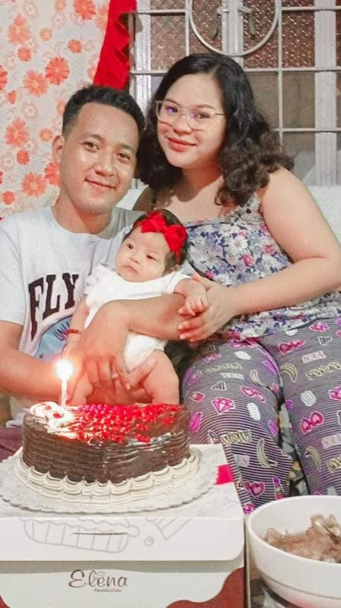
The first major challenge arrived with the pandemic. My studies hung in the balance as my parents struggled financially. It was a crippling choice: pursue my personal dream or alleviate my family's burden. I prayed constantly, surrendering the outcome: "If this path is not meant for me, Lord, I will accept it without worry."
When I finally stepped away from the CPA track, I realized the unexpected truth: there was no deep, agonizing pain. It was a quiet affirmation that this chapter was closed.
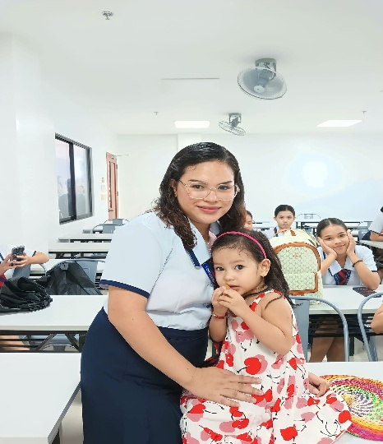
To cope with the sudden change, I dove into work, hoping to outrun the weight of my decision. It was there, amidst the mundane rhythm of a job, that life delivered my most profound surprise: motherhood. Everything changed.
In 2022, I found myself drawn back to the university, this time as a Future Educator. Teaching was never my primary passion, and I enrolled without a firm goal, but I now believe my child was the silent reason, the magnetic north that pointed me toward the education program.

I was enrolled in the Special Education (SPED) program, a field completely unknown to me. Fear immediately set in. I was a mature student, four years older than my peers, and the sight of my former batchmates graduating and succeeding as professionals felt like a stark spotlight on my own pause. I often whispered the painful phrase to myself: "Napag-iwanan" (Left behind).
Hesitation battled determination, yet I continued. My life became a relentless balancing act—a demanding daily performance as a mom, Wife, and Student all at once.
Looking back, the fear and shame have dissipated, replaced by a quiet sense of triumph. I may not yet possess my professional diploma, but I have already achieved a more meaningful success. I have my family, my constant reminder that I have succeeded in the most important roles of my life.
My journey was a detour, but it led me not to a career of calculating wealth, but to a purpose of nurturing potential. I am now Joyce, the resilient mother, devoted wife, and aspiring SPED teacher, ready to embrace the unexpected purpose life chose for me.

